L07: Preparation Assignment Worked Solutions
Name: ___________________

Part I: Use the information in the reading assignment to complete these questions.

- What two conditions must be satisfied in order for a sample mean to be normally distributed?

- The parent population is normally distributed, so the sample mean is automatically normally distributed.
- The sample size is large, and the Central Limit Theorem implies that the sample mean is normally distributed.

- What is the z-score formula for a sample mean that is normally distributed?
z = value – mean/ standard deviation. Z = $\frac{\overline{x}- μ}{σ/\sqrt{n}}$
- Suppose a normally distributed population has a mean $μ=10$ and a population standard deviation$σ=5$.
  - What is the probability the outcome is between 5 and 15?
About 68% using 68, 95, 99.7 rule or 0.6827 “exact”
  - What is the 40th percentile for this population?
10 – 5 (0.25335) = 8.73325
  - What is the z-score for an observation of 18.5?
Z = $\frac{\overline{x}- μ}{σ}=\frac{18.5-10}{5}$= 1.7
  - What is the probability that an observation is greater than 12?
Z = $\frac{12-10}{5}=$0.4 Then use the Normal Probability Applet to find that the probability = 0.3446

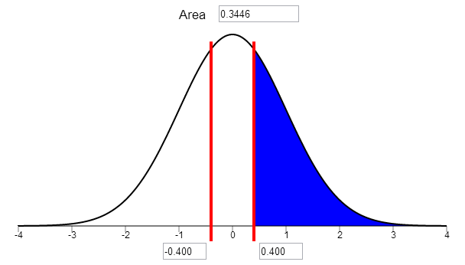
  - What is the probability that an observation is less than 8 or greater than 12?
Z($\overline{x}$<8) = -0.4 probability = 0.3446
Z($\overline{x}$>12) = 0.4 probability = 0.3446
0.3446+0.3446 = 0.6892

Part II:
Suppose Pear Computing sold an average of $μ=45$ pFones per minute in 2011 (yes, that means they sold 23,652,000 pFones in 2011) with a standard deviation of $σ=10$, and they looked at their pFone sales data and determined that they are normally distributed.

- Samples of size $n=4$ are taken from the normally distributed 2011 sales data. What is the shape of the distribution of $\overline{x}$ ?
Normal, because it was taken from a normally distributed parent population.

- Samples of size $n=40$ are taken from the normally distributed 2011 sales data. What is the shape of the distribution of $\overline{x}$ ?

Normal, because it was taken from a normally distributed parent population.

- A sample of size $n=4$ is taken from the normally distributed 2011 sales data. What is the probability that the observed $\overline{x}<40$ ?

Z = $\frac{40-45 }{{10}/{\sqrt{4}}}$ = -1 Probability = about 0.16 using the 68, 95, 99.7 rule or 0.1587 “exact”, using the Normal probability applet. Shade to the left because we want to know the probability that the observed $\overline{x}<40.$

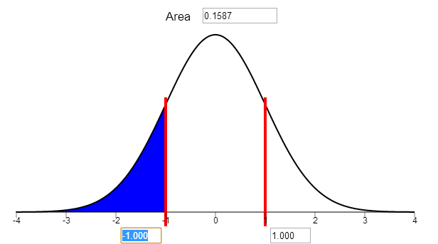

- A sample of size $n=4$ is taken from the normally distributed 2011 sales data. What is the probability that the observed $\overline{x}$ is greater than 35 and less than 55?

Z($\overline{x}$>35) = $\frac{35-45}{{10}/{\sqrt{4}}}$ = -2, z($\overline{x}$<55) = $\frac{55-45}{{10}/{\sqrt{4}}}$ = 2 Probability = about 0.95 using the 68, 95, 99.7 rule or 0.9545 “exact” using the applet.

- A sample of size $n=25$ is taken from the normally distributed 2011 sales data. What is the probability that $\overline{x}$ is greater than 41 and less than 49?

Z($\overline{x}$>41) = $\frac{41-45}{{10}/{\sqrt{25}}}$ = -2, z($\overline{x}$<49) = $\frac{49-45}{{10}/{\sqrt{25}}}=$ 2 Probability = about 0.95 using 68, 95, 99.7 rules or 0.9545 “exact”, using the applet.

- A sample of size $n=25$ is taken from the normally distributed 2011 sales data. What is the probability that the observed $\overline{x}$ is greater than 50?

Z($\overline{x}$>50) = $\frac{50-45}{{10}/{\sqrt{25}}}$ = 5/2 or 2.5. Then type in the z-score into the applet to find that the Probability = 0.00621.

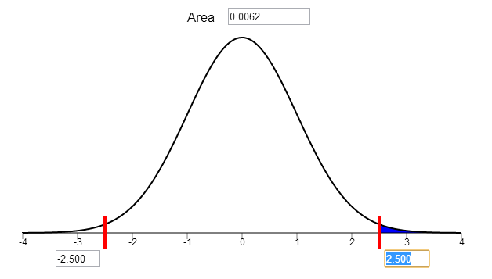

Pear Computing sold an average of $μ=40$ pFones per minute in 2010 with a standard deviation of $σ=12$, and they looked at their pFone sales data and determined that the distribution is right skewed.

- Samples of size $n=4$ are taken from the right skewed 2010 pFone sales data. What is the shape of the distribution of $\overline{x}$ ?
Right Skewed, because the parent population was right skewed and the sample size is very small.

- Samples of size $n=40$ are taken from the right skewed 2010 pFone sales data. What is the shape of the distribution of $\overline{x}$ ?

Approximately Normal, because although the parent population was right skewed the sample size was large.

- Is there a theorem that justifies your answer to question 11? What is the name of the theorem?

Central Limit Theorem

- A sample of size $n=4$ is taken from the right skewed 2010 pFone sales data and you want to know the probability that the observed $\overline{x}<35$ . Can you compute this probability using the normal probability applet with the information you have? Why?

No, the distribution is not normal, and the normal probability applet is only for normal distribution.

- A sample of size $n=36$ is taken from the right skewed 2010 pFone sales data. What is the probability that the observed $\overline{x}$ is greater than 36.5?
Z ($\overline{x}$>36.5) = $\frac{36.5-40}{{12}/{\sqrt{36}}}=$ -1.75, then type this z-score into the normal probability applet and shade to the right to find that the Probability = 0.9599.

- A sample of size $n=36$ is taken from the right skewed 2010 pFone sales data. What is the probability that the observed $\overline{x}$ is between 37.5 and 42.5?

Z$(\overline{x}$<37.5) = $\frac{37.5-40}{{12}/{\sqrt{36}}}$ = -1.25, then type this z-score into the normal probability applet and shade to the right to find the Probability = 0.1056
Z($\overline{x}$>42.5) = $\frac{42.5-40}{{12}/{\sqrt{36}}}=$ 1.25 Probability = 0.1056
1-0.1056-0.1056 = 0.7888

